Top of Form

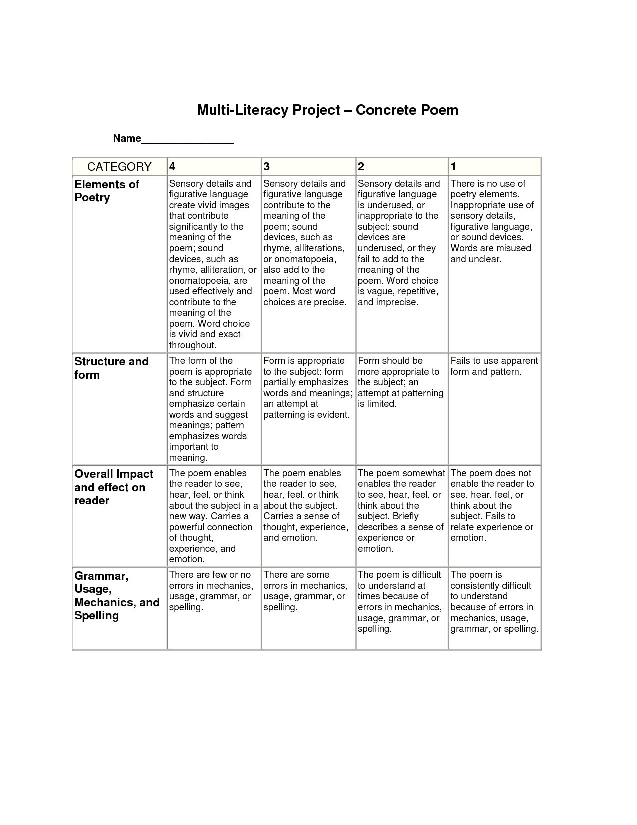Bottom of Form

**Name: ___________________________________________**

|  |  |  |  |  |
| --- | --- | --- | --- | --- |
| **CATEGORY** | **5** | **4** | **3** | **1-2** |
| **Elements of Poetry** | Sensory details and figurative language create vivid images that contribute significantly to the meaning of the poem; sound devices such as alliteration, or onomatopoeia, are used effectively and contribute to the meaning of the poem. Word choice is vivid and exact throughout. | Sensory details and figurative language contribute to the meaning of the poem; sound devices, such as rhyme, alliterations, or onomatopoeia, also add to the meaning of the poem. Most word choices are precise. | Sensory details and figurative language is underused, or inappropriate to the subject; sound devices are underused, or they fail to add to the meaning of the poem. Word choice is vague, repetitive, and imprecise. | There is no use of poetry elements. Inappropriate use of sensory details, figurative language or sound devices. Words are misused and unclear. |
| **Structure and Form** | The form of the poem exceeds teacher’s expectation. Form and structure emphasize certain words and suggest meanings; pattern emphasizes words important to meaning. | Form of the poem meets teacher’s expectations. Form partially emphasizes words and meanings; an attempt at patterning is evident. | Form of the poem is basic. An attempt at patterning is limited. | Form of the poem is below teacher’s expectations and/or unoriginal. Fails to use apparent form and pattern. |
| **Overall Impact and Effect on Reader** | The poem enables the reader to see, hear, feel, or think about the subject in a new way. Carries a powerful connection of thought, experience, and emotion. | The poem enables the reader to see, hear, feel, or think about the subject. Carries a sense of thought, experience, and emotion. | The poem somewhat enables the reader to see, hear, feel, or think about the subject. Briefly describes a sense of experience or emotion. | The poem does not enable the reader to see, hear, feel, or think about the subject. Fails to relate experience or emotion. |
| **Grammar, Usage, Mechanics, and Spelling** | There are few or no errors in mechanics, usage, grammar, or spelling. | There are some errors in mechanics, usage, grammar, or spelling. | The poem is difficult to understand at times because of errors in mechanics, usage, grammar, or spelling. | The poem is consistently difficult to understand because of errors in mechanics, usage, grammar, or spelling. |

**Rubric for Concrete Poem**

**Comments:**