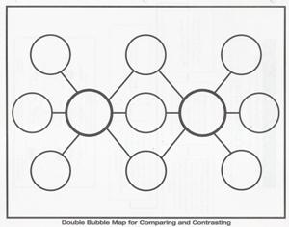

**Coming-of-age   
in Music**

9.

6.

4.

8.

10.

1.

2.

7.

5.

3.